**LAB 5 REPORT**

**Objective:**

* This report tells you about how to create an object storage in AWS and how to host a file.
* In this assignment the main objective is to host a static html file.

**Introduction:**

* In AWS (Amazon Web Services) S3 is the object storage, we are going to host a static html file in this storage and let’s see how that works.

**Prerequisites:**

* AWS Account

**Implementation:**

* First create a AWS account and make sure that you have taken the free plan, the free tier plan will be enough to host a object file.
* Now, login to the AWS console and click down the services arrow, you will find the S3 option over there, click on that and you will find the create bucket option.

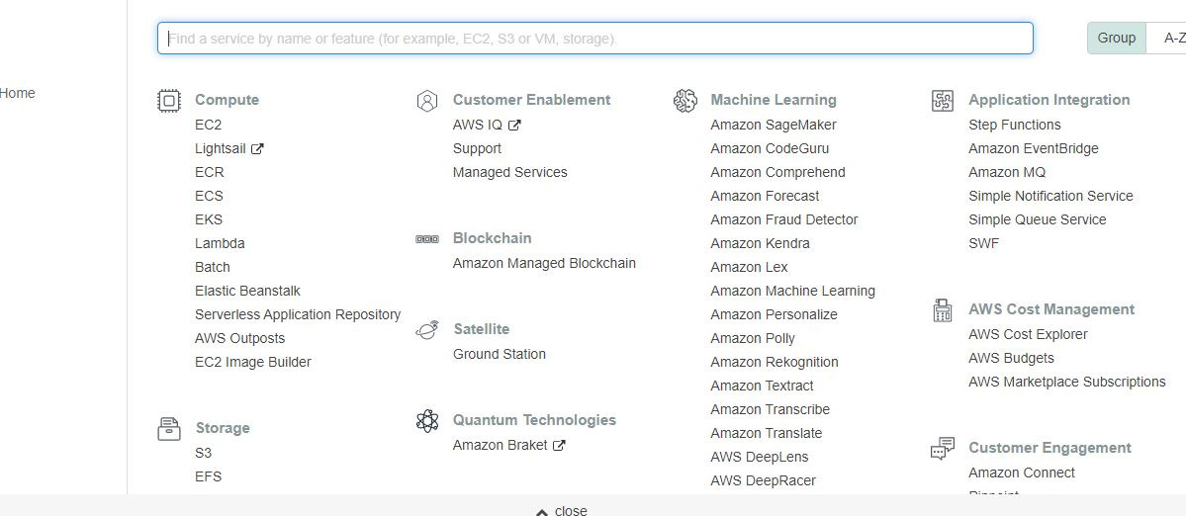

* Click on create, now you have to give the bucket a name and the name should be unique and after that select a region.

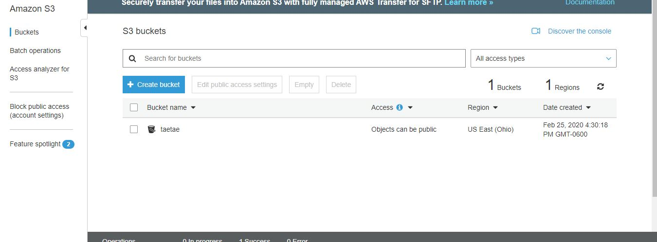

* Now, click next until you create the bucket, just keep the default options while creating it and cluck next.
* Now click on the bucket you have created, there you will find an option as upload, click on that and it will ask you to select the files, select the required files and upload them.

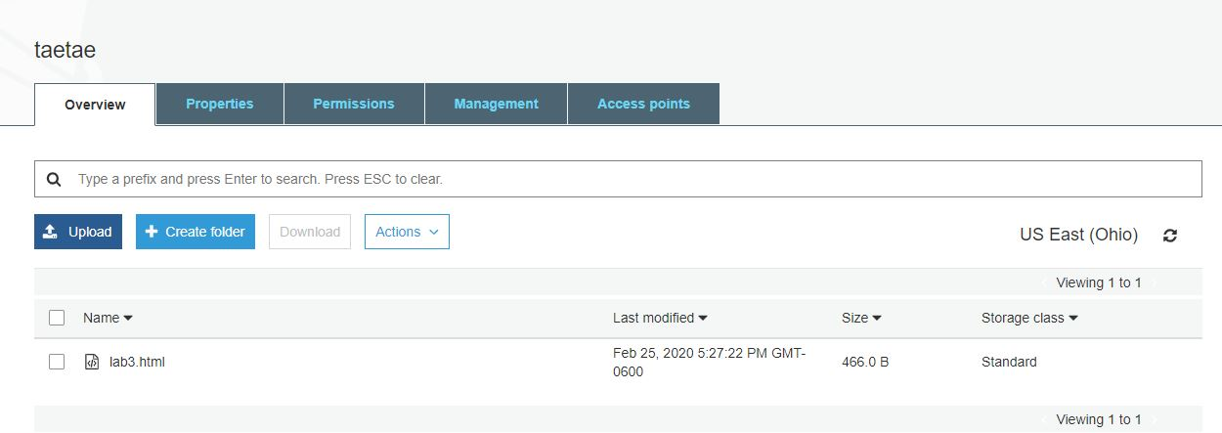

* Now, the final step you have to do is host the file that you have uploaded, for that go to properties and click on static website hosting and fill out the details of the file and save it and now go back and click on static website hosting again.

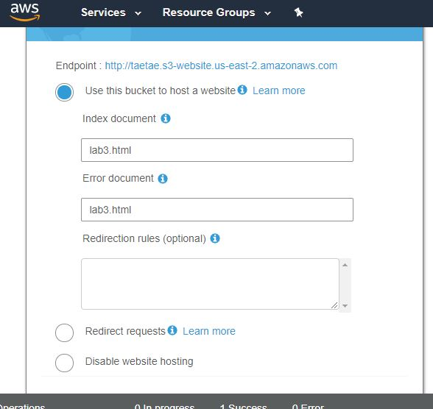

* Here now you have to find an end point link at the top of the file, that is how you host a file in AWS object storage.

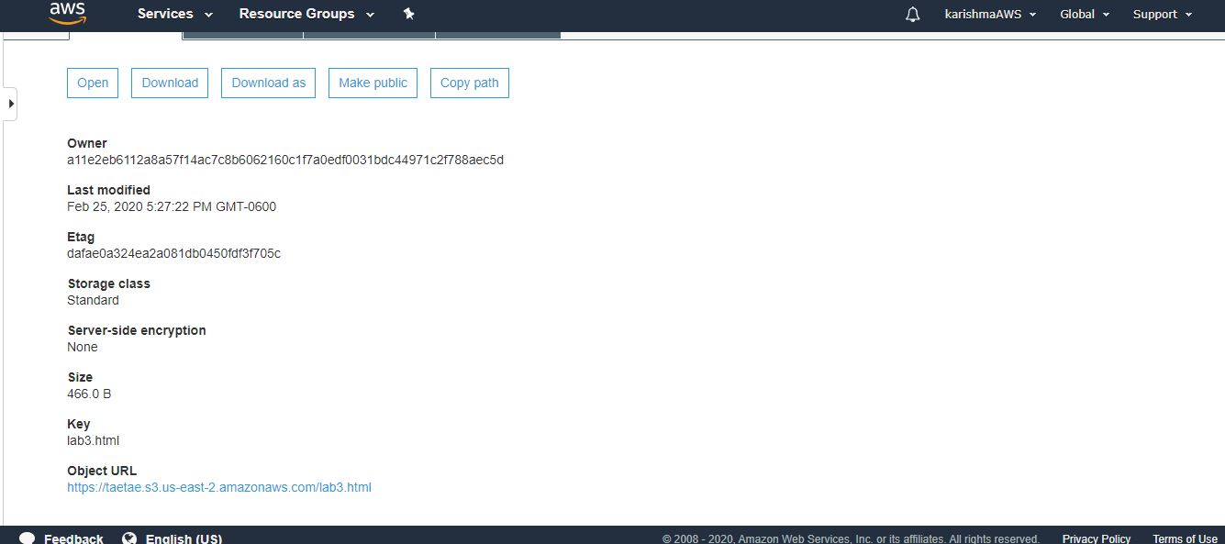

* In the above image you can see that there is an option to make the file public, you have to click on that option so that when you click on the link of end point ,then it will open your file in the browser.

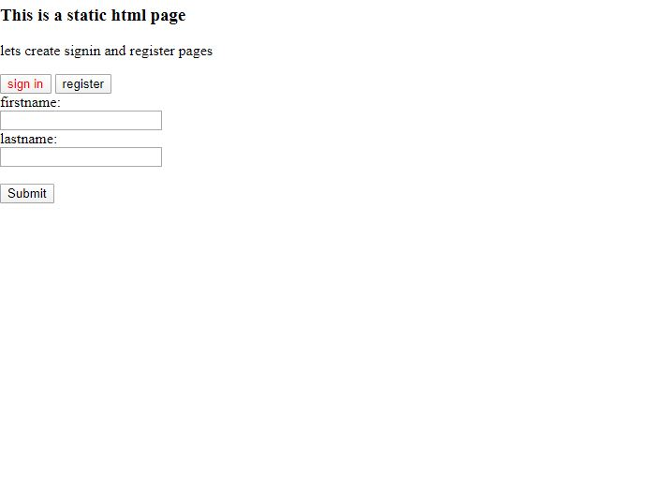

**Limitations:**

The only limitation in doing this when you try to upload files of large size that object storage cannot process, the AWS ask you to pay.

**Conclusion:**

* In this lab assignment, we learned what is object storage and how to create a bucket in AWS and how it works.
* We learned how to host a static html file into AWS S3 bucket.

**Reference:** <https://dev.to/samueldaviddelacruz/how-to-host-your-static-web-app-on-aws-s3-in-10-steps-3kgp>

**Done by_**

Name class id

Karishma ,yallanki 29

Tejaswi , guturu 16